Resources for
Reading and Writing the Micromemoir
Newberry Library, Sept 26, 2020
Julie Benesh juliebnsh@gmail.com

The Coming of the Coming of Age by Beth Ann Fennelly

We were vacationing on a small lake in Canada. I’d walked the pineneedle path to the store, the kind of place lichened with shingles, bell on the screen door, bowl of water for the store dog. The kind of place that sold a bit of everything, beef jerky and buttons and shoe polish and fly paper. I cased the tiers of candy. I was six, would have been happy eating nothing but Pixy Stix and Pop Rocks and Bottle Caps. Lik-M-Aid Fun Dip and candy cigarettes that gave a puff of chalky sugar.
Waiting in line, I felt a hand settle onto my head: the woman behind me, conversing with the clerk. She began stroking my hair. I waited, obedient, patient, to pay, and the woman continued chatting and stroking, rhythmically, unhurriedly, my hair an instrument she strummed to lyrics about summer traffic, worse than last year, eh? And did you hear Mary’s eldest is moving home?
Then it was my turn, and as I addressed the clerk, the woman behind snatched her fingers back as if they’d been scorched. “Oh!” she cried, and I turned. “I’m sorry, I’m terribly sorry! I thought for a minute you were my daughter!” I gazed at her, surprised only at her embarrassment. Of course she’d want to pet me.
Diet of nothing but sweetness, expectation of nothing but affection. You can imagine what this world would make of me.

http://gulfcoastmag.org/journal/29.1/6-micro-memoirs/

Past-Present, Taste-Touch, Objects, Humor

Proof by Beth Ann Fennelly

My other seined the waters of our childhoods. She gathered everything into the nets of her fingers: schoolwork, artwork, mementos. My mother did not recycle. Nor did she dispose. She was indisposed to it. Gathered now it seems a kind of evidence, but of what? Consider the card she saved from the nurse who helped deliver me. Second daughter! Looks like you’ll have to wait for next time to get that son! Consider my mother pasting that into my baby book. It would seem to imply I’ve been a disappoint from the moment I was born.

Past-present, Objects, Extended Metaphor, Humor

From Heating and Cooling: 52 Micro-Memoirs
BETH ANN FENNELLY
REDUCED SENTENCES

I Come From a Long Line of Modest Achievers

I’m fond of recalling how my mother is fond of recalling how my great-grandfather was the very first person to walk across the Brooklyn Bridge on the second day.

Practical

Bought a bag of frozen peas to numb my husband’s sore testicles after his vasectomy.

That night I cooked pea soup.

I Knew a Woman

Everything she had was better than everything the rest of us had. Not by a lot. But by enough.

Married Love, 1

When we snuggle, my left hand finds purchase on his back cyst. My home button.

Why I’m Switching Salons

“We can put on a topcoat with glitter,” said the manicurist. “We all know how you feel about glitter.”

Copulation Couplet
--for the birds and other open-minded parties--

Birds without penises do it like this:
press vent to vent and pass the sperm, called “the cloacal kiss.”

“If You Were Born Catholic, You’ll Always Be Catholic”

My husband sits up after changing the van’s busted tire, grease on his forehead, and I think—though it’s been thirty years—it’s Ash Wednesday.

Married Love, 2

There will come a day—let it be many years from now—when our kids realize no married couple ever needed to retreat at high noon behind their locked bedroom door to discuss taxes.

No, It’s Not a Coincidence

In every book my husband’s written, a minor character named Colin suffers a horrible death. This is because the boyfriend I had before I met my husband was named Colin. In addition to being named Colin, he was Scottish, and an architect. So it’s easy to imagine my husband’s feelings of inadequacy. My husband cannot build a tall building of many stories. He can only build a story, and then push Colin out of it.

Returning from Spring Break, Junior Year at Notre Dame
Swapped the rosary on my bedpost for Mardi Gras beads.

Still Have the Playbill
I peaked early, fourth grade. I had the lead in Mary Poppins. Mr. Banks was played by Vince Vaughn. Yes, that Vince Vaughn, though at that point he was just a kid, just another nobody like the rest of us. He didn’t go to Hollywood until after high school.

I don’t recall him as being particularly talented.

The Sum of What I Recall, One Year Later, from the Prague Walking Tour

Kafka was not the unhappy person we generally assume him to be.

When They Grow Up

My oldest child will hate me because I wrote an entire book about her. My middle child will hate me because I wrote hardly a word about him. But the baby; ah, the baby. When I write about him, I call it fiction, and I’m always sure to mention he has a big penis.

(Don’t Think About the) Pink Elephant

Sometimes at the end of yoga I’m finally relaxing into that calm where I’ve forgotten my to-do list. That’s when the instructor says, “Don’t think about your to-do list.” Suddenly it’s back, and it’s longer, because now it includes forgetting my to-do list.

A Few Weeks Later, the Recorded But Not Yet Released “Dock of the Bay” Would Become History’s First Posthumous #1 Hit

It was storming, that December day in 1967, when the two-engine plane containing twenty-six-year-old Otis Redding and his back-up band, the Bar-Kays, took off from Cleveland. Just a few miles short of the Madison, Wisconsin airport, the plane crashed into Lake Monona. The crash killed Otis, his pilot, his manager, and four out of five Bar-Kays. Only the lonely trumpeter survived.
He was the one who played Taps.

Married Love, 3

As we lower onto the December-cold pleather seats of the minivan, we knock hands: both of us reaching to turn on the other’s seat warmer first.

https://aprweb.org/poems/reduced-sentences

Missing Notes by Paula Carter

Oh, mother, I have begun to sing. I have begun to sing on car trips with my partner’s sons who sit in the back and ask me to stop. Which I don’t. I sing while doing housework, cleaning floors and counters. And when I recognize some forgotten tune hijacked by the television I let my voice ring out. Not to be stopped. Not to be interrupted. Just a moment, just a moment, I’m singing.
I sing songs I hardly know, missing words or notes, but that doesn’t stop me, as I remember it never stopped you, mother, as if you were a bird regurgitating them into my beak and now I am spitting them back up, looking for my own young to feed.
I know why now, why you sang while doing the dishes, while driving the car, while putting on your cold cream, right up around your vibrating throat. A I lift my voice above the silence, I know how it feels to send out a message in song to those around you who seem to be deaf. You try to hit a notes so high it can penetrate your own heart, which has also been deafened.

From No Relation, Black Lawrence Press, 2017.

Past-Present, Touch-Sound
Feel Like Myself by Amy Krouse Rosenthal

…I have been wearing the same perfume, Fracas, since eighth grade, when my boyfriend marc’s mother introduced it to me. When I run into people I haven’t seen for a long time they invariably remark, You smell the same, you smell like Amy. I wear mascara and eyeliner, but I never, ever wear rouge, no matter how pale I am; I must have a teen memory of feeling makeup-y and clownlike with it brushed along my freckled cheekbones. I took my watch off when I was twenty-three and haven’t worn one since. I have had long hair most of my life; I’ll occasionally get bored and cut it, then start to not feel like myself and grow it back. If I don’t like the shoes I have on, I feel plain, even if I like the rest of my outfit. I hate wearing socks and resort to them only in extreme weather condition. I simply do not like the way they feel on my feet…I have not worn panty hose since I left for college, no matter how dressy the occasion; they feel like the leg equivalent of foundation makeup: false, itchy, and not me. I like my toenails painted and my fingernails short and unpainted. I do not feel like myself in nice jewelry-I wear a two-dollar thumb ring and a five dollar toe ring. I stopped wearing earrings altogether in my late twenties. I gravitate toward thrift-shop jackets. I am not a purse person. Maybe it has to do with being small; I feel like a girl playing dress-up, like what am I doing with this fancy thing. I bought a brown leather backpack in Greece when I was twenty-four and have been carrying it around ever since. It is now very worn-in and feels very much like me.
From Encyclopedia of an Ordinary Life. Broadway Books, 2005

Past-Present, Objects (Personal), Touch

Tiny Love Story - Stephanie Parent

After all the kind and cruel words, after the realization that I could never live by his rules, after the anger and the wrenching relief of being free, I remember this:

When he moved into his house, he bought two nightstands, one for each side of a bed
made for two. We christened that bed, but I wouldn’t spend the night.

The next time I came over, one of the nightstands was gone.

“I only needed one,” he said. I couldn’t tell if the twist in his voice was real, or just an
echo of the twist inside my gut.

Sometimes I see furniture abandoned on the street: scratched end tables, chairs with
broken legs. More rarely, something shiny, the smell of new leather, hardly used. My mind flashes to him.

His absence is a missing piece of furniture, in a room inside of me.

https://www.sadgirlsclublit.com/post/tiny-love-story-stephanie-parent

Objects, Past-Present, Smell
Dear Yoga by Julie Benesh

I don't remember the first time I met you. It's like you were always around, dressed down and calling yourself Stretch at the end of those cardio classes, grinding on Mat or else glammed up in those videos looking like a different entity altogether. I went through the motions with your freak cousin Gymnastics back in the day, although she actually scared the crap out of me, and I wanted no part of your virtue-signaling, humble-braggin’ Uncle Meditation. And, frankly, nothing I heard about you, or saw on Instagram, made me exactly eager to get to know you better. Basically you seemed like a phony, high maintenance poser.
Were we supposed to meet at some fancy, exclusive club, or were you willing to Netflix and chill?
Do we need expensive clothes and equipment, or can we wear anything or nothing?
How much third party participation is ...normal? Were we supposed to decline those hands-on adjustments, or relax and enjoy them?
If you are really up for anything with anyone everyone, why’s there all that competition for your attention? Are you so easy… or just a tease?
And, yeah, supposedly, occasionally, you kill or maim your lovers, which you might expect from someone named, like, Boxing, or Hockey. But Yoga?
And whaddup with the Sanskrit. Seriously?! Hello…have you heard of cultural appropriation?
Of course eventually I had to stick my legs up your wall. On a dare, to shut everyone up; a rite of passage. The shame! But it brought us together, so I'm mostly grateful. The first time I slept with you-- you called it “savasana”-- I saw visions. I'd never felt that way before.
Now it's been years, and it is still so good. Sometimes three times a day for weeks; sore in that good way. Other times I get busy, forget to make an effort, can't find the time or energy to do you properly, but like they say, even just to lay there and breathe is still doing Yoga! And every time, alone at home or out in a group of friends or strangers, is different, and every time is wonderful.
I especially love doing you outside, like on North Avenue Beach or in Lincoln Park. It's weird, I admit, when tourists from Schaumburg walk by and take pictures of our Down Dog or a video of our Happy Baby, but I don't blame them. You are beautiful. Together, we are beautiful.
And those teenage boys who mock us, mimicking our poses, our passion, our awkward tumbles? Ten years from now their girl (or boy)friends will be dragging them to you, traipsing late into crowded, hot rooms, as we hop from the tide of man-sweat pooling at their feet.
I am but a Humble Warrior and I don't deserve you. But just like they said, as long as I'm breathing, I'll be doing you. DTY forever.
Namaste.

https://howlingmadreview.com/julie-benesh/

Past-Present, Extended Metaphor, Touch, Humor

More by Julie Benesh
http://matterpress.com/journal/2019/05/01/cnf-flyover-girls/

https://changesevenmag.com/interventions-by-julie-benesh/

https://www.cleavermagazine.com/how-to-try-to-be-cute-by-julie-benesh/

http://www.greenbriarreview.com/Julie-Benesh---How-to-Not-Write-Fiction.html

https://memoirmag.com/nonfiction/bombardment-by-julie-benesh/

https://howlingmadreview.com/julie-benesh/

METROPOLITAN DIARY

‘We Both Wound Up at a Corner Waiting for the Light to Change’
An awkward offer to help, and more reader tales of New York City in this week’s Metropolitan Diary.
- July 5, 2020

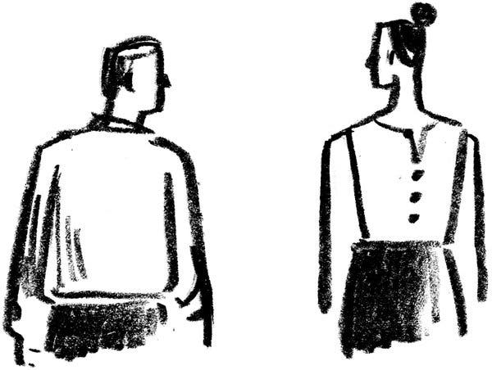
Image

Unbuttoned
Dear Diary:
One day last spring, I was walking west from Alphabet City to Pier 34 to watch the sunset.
Somewhere in the West Village, I noticed a young woman walking the same direction a few paces in front of me. I watched for a block or two as she kept reaching one arm around behind her to try to button a loose button at the back of her blouse.
I wanted to help her, but I was nervous about asking and I didn’t want to bother a stranger, especially over something as personal as a loose blouse button.
After a while, we both wound up at a corner waiting for the light to change. I took off my headphones.
“I’m sorry to bother,” I said, “but could I help you with that?”
“Oh my God,” she said. “I’ve been wanting to ask you for blocks but was too nervous to ask.”
— Perry Khalil

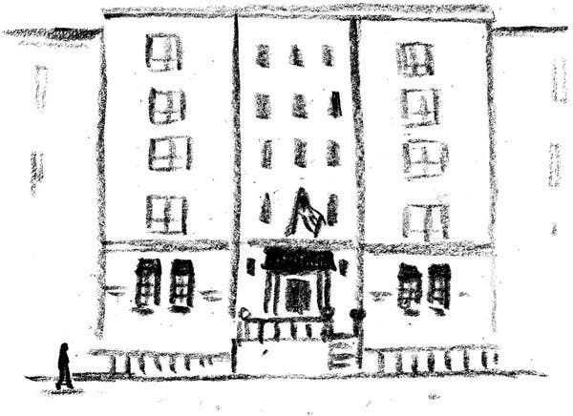

The Old Place
Dear Diary:
As I walked across 11th Street to visit friends in the Village, the Larchmont Hotel caught my eye. An S.R.O. 50 years ago, it had been refurbished as a boutique hotel.
I had rented a room there while I was in graduate school. Living just opposite the elevator, I heard clanks at all hours. Feet shuffled. High heels clacked. Doors closed.
Two toilets and one shower served seven occupants on each floor. Five rooms opened off the corridor, with a more spacious room at each end. I coveted the larger room with tall windows overlooking the street.
In my room, a twin bed took up one wall; a sink hung on another. Most nights I cooked a little meal on a two-burner hot plate.
Days come clearest now. Grilled cheese sandwiches at the Joe Jr. Diner, occasional tea with a classmate. Each morning I walked to the New School library, where a flow of students returned to the same seats.
Fifty years later, my home now feels huge. Maybe it’s expanded since my husband Jerry died. Through the window, I glimpse the Taconic Range. Geese traverse the sky. Yet the hotel resides within me: radio, hot plate, stacked textbooks.
Morning stillness links my ranch house and the Larchmont, a silence heightened by refrigerator rumblings, furnace clicks, a snowplow passing.
I’ve been alone before.
— Cecele Kraus
About micormemoir (and still more Beth Ann Fennelly)
https://www.writermag.com/improve-your-writing/nonfiction/micro-memoir/
https://www.writermag.com/improve-your-writing/nonfiction/ten-tips-tiny-truths/
https://examples.yourdictionary.com/reference/examples/short-memoir-examples.html
https://truestorieswelltold.com/?s=Flash+Memoir
https://www.marketwatch.com/story/how-poet-beth-ann-fennelly-discovered-she-had-accidentally-written-a-micro-memoir-2017-10-12
https://brevity.wordpress.com/2018/06/04/beth-ann-fennelly-on-heating-cooling-and-safety-scissors/
https://www.ajc.com/entertainment/books--literature/short-stories-pack-hefty-punch/Bh1ljgTO4fTOpjG7scfurK/
https://floridareview.cah.ucf.edu/article/interview-beth-ann-fennelly/
http://www.ninthletter.com/fennelly
https://rosemetalpress.com/books/the-rose-metal-press-field-guide-to-writing-flash-nonfiction/
Auster, Paul. The Red Notebook. Faber & Faber, 2014.
https://www.nytimes.com/2020/08/18/style/tiny-modern-love-stories-coronavirus-the-other-iris.html

